**Aim:**

To demonstrate **Infrastructure as a Service (IaaS)** by creating a Virtual Machine (VM) using Microsoft Azure Public Cloud, and configuring it with required CPU and memory.

**Procedure:**

1. Login to Azure Portal

* Open https://portal.azure.com
* Sign in with your Azure account.

2. Create a Resource Group

* In the search bar, type Resource Groups → Click Create.
* Enter a Name (e.g., IaaS-RG).
* Choose a Region (e.g., East US).
* Click Review + Create → Create.

3. Create a Virtual Machine

* In the search bar, type Virtual Machines → Click Create → Azure Virtual Machine.
* Select the previously created Resource Group.
* Enter VM name (e.g., IaaS-VM).
* Choose Region (same as resource group).
* Select Image (e.g., Windows Server 2019 or Ubuntu 20.04 LTS).
* Choose Size (defines CPU & RAM):
  + Example: *Standard B1s* → 1 vCPU, 1 GB RAM (minimum configuration).
  + Or choose larger as required.
* Set Administrator account credentials.

4. Configure Networking

* A Virtual Network (VNet) and Subnet will be created automatically.
* Configure Inbound Port Rules:
  + Allow RDP (3389) for Windows VM.
  + Allow SSH (22) for Linux VM.

5. Review + Create

* Click Review + Create → Wait for validation.
* Click Create → Deployment starts.

6. Access the VM

* After deployment, go to the VM resource.
* Copy the Public IP Address.
* For Windows VM: Use Remote Desktop Connection (mstsc).

**OVERVIEW:**

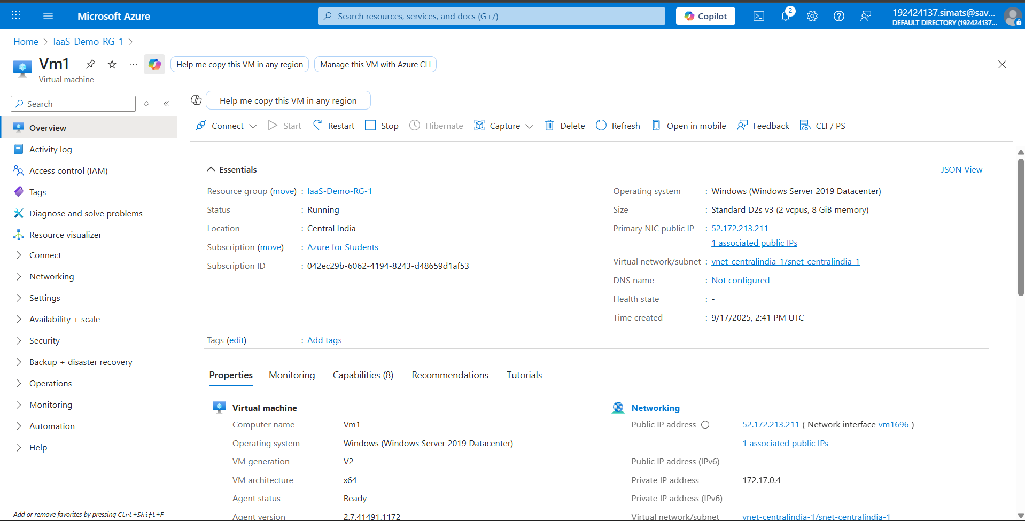

**OUTPUT:**

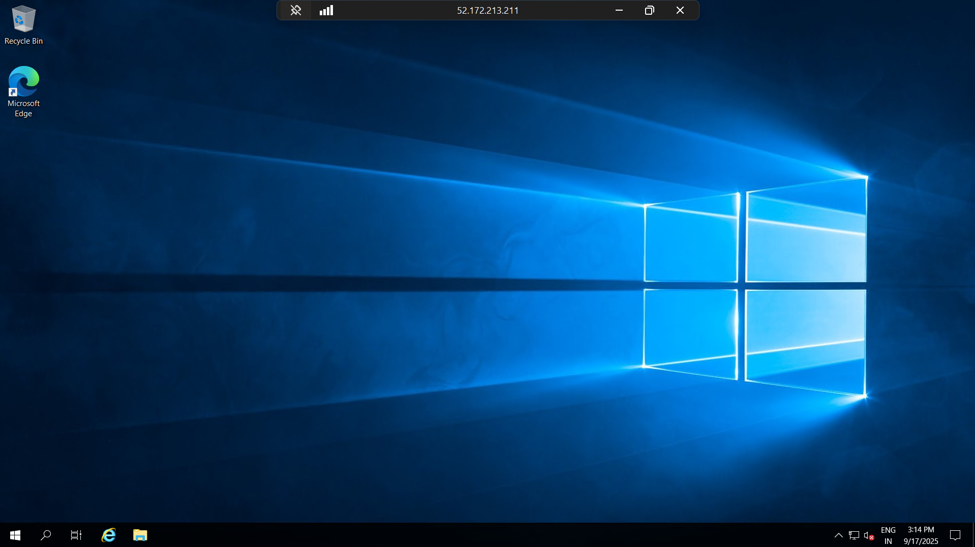

**Result:**

A Virtual Machine was successfully created on Azure Cloud using the IaaS model, with required CPU and memory configuration. The VM is accessible over the internet using its Public IP, demonstrating how Azure provides infrastructure resources as a service.